Q4. Speed up the getpid system call (easy)
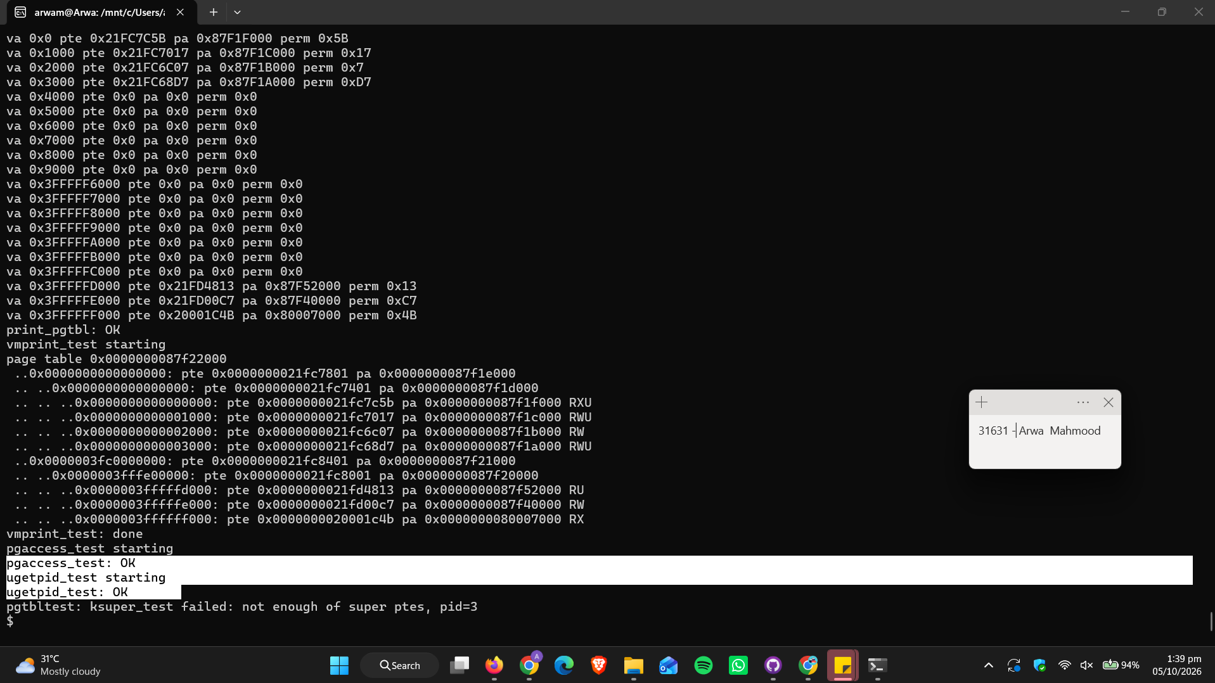

Q. Which other xv6 system call(s) could be made faster using this shared page? Explain how.
Ans. ‘getppid’ is the best fit. Add an int ppid field to struct usyscall and let user code read it. The kernel must keep it correct. Set it in fork for the child. Update it in reparent() when a parent exits, because the child's parent becomes init.
- uptime also works. Map one read-only page that all processes share, and let the timer interrupt (clockintr) write the tick count into it. User code then reads ticks directly.
The reason why its faster: a normal system call needs a trap into the kernel. That means saving registers, switching page tables through the trampoline, running the handler, and returning. Reading the shared page is one memory load. This only suits calls that read values the kernel already has and that have no side effects.

